**DC CIRCUITS**

**Electrical Network:**

A combination of various electric elements (Resistor, Inductor, Capacitor, Voltage source, Current source) connected in any manner what so ever is called an electrical network. A network or circuit that can be AC or DC is the combination of active elements (power supply sources) and passive elements (resistors, capacitors and inductors).

**Types of Electric Circuit Elements:**

**Linear elements**:

Linearity is the property of an element describing a linear relationship between cause and effect. In an electric circuit, a linear element is an electrical element with a linear relationship between current and voltage. Resistors are the most common example of a linear element; other examples include capacitors, inductors.

**Non-linear elements**:

A nonlinear element is one which does not have a linear input/output relation. In a diode, for example, the current is a nonlinear function of the voltage.

**Passive element:**

The element which consumes energy (or absorbs energy) rather than produce energy and then either converts it into heat or stored it in an electric or magnetic field called passive element. Example: Resistor, Inductor, Capacitor etc. Passive network contains circuit elements without any energy sources.

**Active element:**

The elements which supply or generate energy is called Active element. Examples: Voltage and Current sources, Generators, Batteries etc. Active network containing energy sources together with the other circuit elements.

**Bilateral element:**

Conduction of current in both directions in an element with same magnitude is termed as Bilateral Element. Example: Resistor, Inductor, Capacitor etc. The element in which the voltage current relationship is same for current flowing in either direction is known as bilateral element. Example- Resistor, Inductor, Capacitor etc.

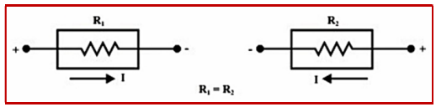

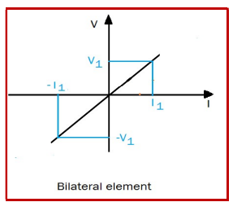The above figure shows a bilateral element can conduct from both sides and offers same resistance for current from either side.

**Unilateral element:**

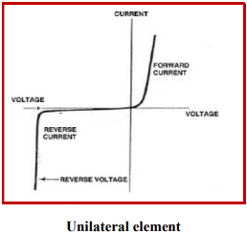The element in which the voltage current relationship is not same for current flowing in either direction is known as unilateral element. Example- vacuum tubes, diodes, transistors etc.

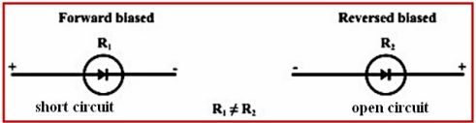

**Source Transformation**

**Linear and Nonlinear Circuits**

**Sources of Electrical Energy:**

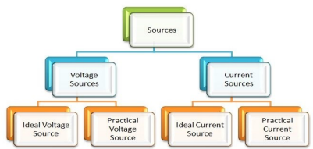There are two types of sources of electrical energy: voltage source and current source.

**VOLTAGE SOURCE**

An **ideal voltage source** is two-terminal element which maintains a constant terminal voltage regardless of the value of the current through its terminals. The terminal voltage of ideal voltage source is independent of the current flowing through it. It has zero resistance.

An ideal voltage source has following features:

1) The output voltage remains absolutely constant whatever be the value of the output current.

2) It has zero internal resistance so that voltage drop in the source is zero.

3) The power drawn by the source is zero.

**Symbol of Ideal Voltage Source:**

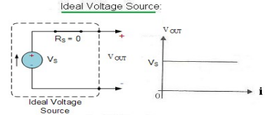

**An ideal voltage source and its V-I characteristic**

In a **practical voltage source**, voltage across the terminals of the source keeps falling as the current through it increases. This behaviour can be explained by putting a resistance in series with an ideal voltage source. Then we have the terminal voltage V**out** as V**out** = V**s** - iR**s** where i is the current flowing and RS the internal resistance of the ideal voltage source of voltage VS. The practical voltage source approaches the ideal voltage source in the limit RS becoming zero.

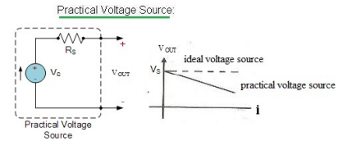

**A practical voltage source and V-I characteristic**

**CURRENT SOURCE**

An **Ideal current source** is a two-terminal circuit element which supplies the same current to any load resistance connected across its terminals regardless of the value of the terminal voltage. It is important to keep in mind that the current supplied by the current source is independent of the voltage of source terminals. It has infinite resistance It can be noted from model of the current source that the current flowing from the source to the load is always constant for any load resistance i.e., whether RL is small (VL is small) or RL is large (VL is large).

An ideal current source has following features:

1) It produces a constant current irrespective of the value of the voltage across it.

2) It has infinite resistance.

3) It is capable of supplying infinite power.

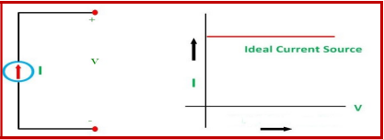

**An ideal current source and its V-I characteristic**

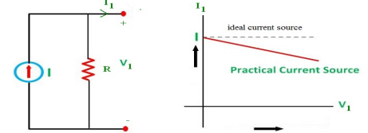In a **practical current source**, the current through the source decreases as the voltage across it increases. This behaviour can be explained by putting a resistance across the terminals of the source. Then the terminal current is given by **I**1= I- (V1/R)

**A practical current source and its V-I characteristic**

**Symbol of Independent Current Source:**

